Appendix 6 Medium term trends: the case of a declining wage share

A continuously declining wage share over the sample period is an important stylised fact for the European economy. In our empirical analysis we allow for two mechanisms which allow the model to match this fact, namely a declining share of overhead labour and a secular increase in the mark up of prices over marginal cost. Unfortunately both shocks are not directly observable; however, they can be identified by using the model because they affect first order conditions differently. The overhead labour shock only affects the labour demand equation while the mark up shock affects labour demand and investment in a similar fashion. Both explanations have some empirical validity. It is likely that structural reforms in the goods market and in particular large scale privatisations which occurred in various euro area member states over the sample period may have lead to a decline in overhead labour. It is also likely that the economy-wide mark up has increased over the sample period due to an increasing share of services in total output. As documented in many sectorial studies on mark ups (see for example Oliveira Martins et al., 1997) the service sector tends to have higher mark ups (the absence of both shocks in the US case is also consistent with a relatively stable US wage share). In the following we use the model in a counterfactual analysis in order to first determine the relative importance of the two explanations in accounting for the evolution of the wage share and second for explaining the economic consequences of these trends.

As can be seen from Figures A6.1 and A6.2 our estimates indicate that the share of overhead labour in total employment LOL has fallen by about 20% points and mark ups have increased by about 5% points. As shown in figure A6.3, the decline in overhead labour explains about 50% of the decline in the wage share. Both effects explain a large fraction of the decline (60-70%).

The reduction in overhead labour increases productivity without increasing the marginal product of production workers (marginal productivity of labour actually falls), this leads to a decline in the wage share. Because firms can supply the same output with less labour and the marginal product of labour has declined, the reduction in overhead labour does not by itself lead to an increase in factor demand. In fact it reduces the demand for labour since the reduction of fixed costs reduces the marginal product of labour. Therefore there is a new equilibrium with less labour input, lower GDP, lower real wages but higher average productivity.

The increase in the price mark up affects the measured mark up directly and leads to a reduction of both factor inputs. In contrast to a reduction in overhead labour the mark up shock reduces labour and capital inputs simultaneously.

Finally, we can ask the question whether both shocks acted independently or whether there is a correlation between them. Theoretically it is plausible that a reduction in overhead labour could have removed entry barriers and thus have led to a reduction in mark ups, suggesting a positive correlation, i.e. corr(lol,eta) > 0. Alternatively it is also possible that an increase in the mark up could have increased overhead labour via some rent sharing agreements between workers and firms, implying a negative correlation, i.e. corr(lol,eta) < 0 , and therefore restrict the decline in LOL. A small negative correlation (corr(lol,eta) = -0.22) can be observed in the reconstruction of the historical shocks (smoothed shocks).

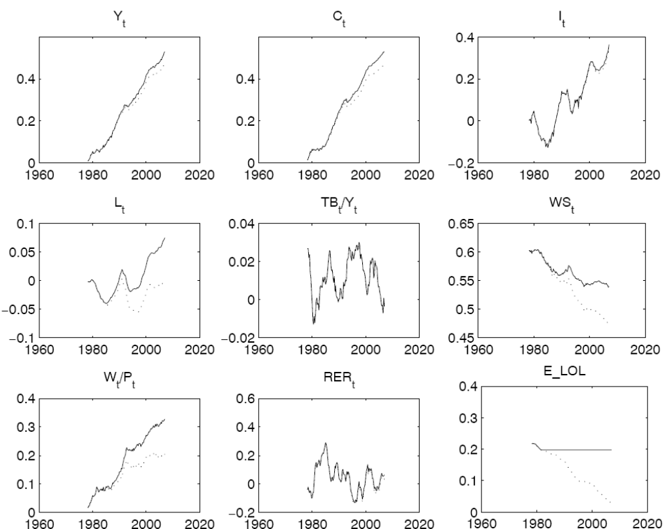

FIGURE A6.1 Counterfactual experiment:
solid lines are for the case when the level of LOL remains fixed at the values of begin of 80’s; dashed lines show the actual data

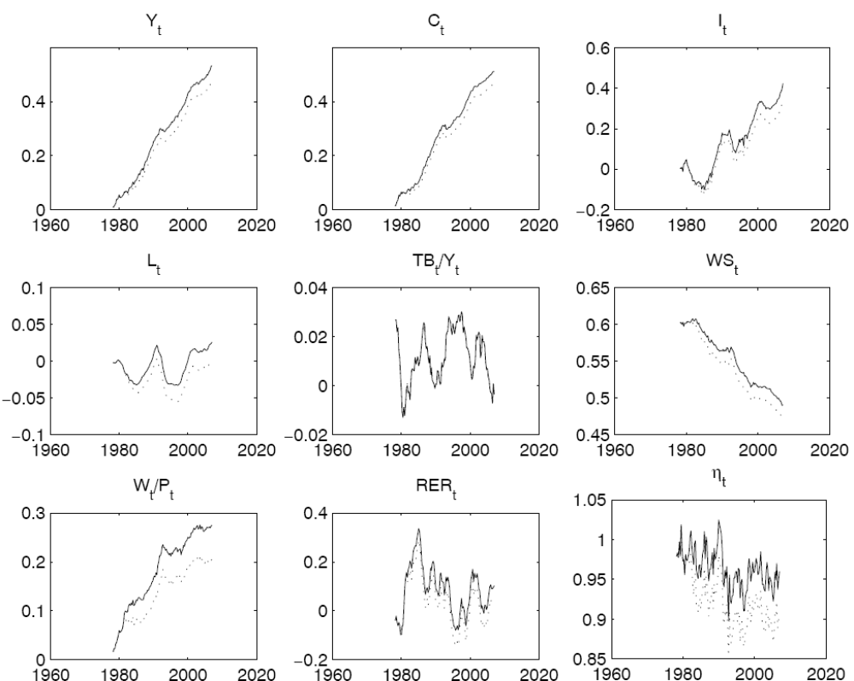

FIGURE A6.2. Counterfactual experiment:
solid lines are for the case when the level of mark-up shocks remains fixed at the values of begin of 80’s; dashed lines show the actual data.

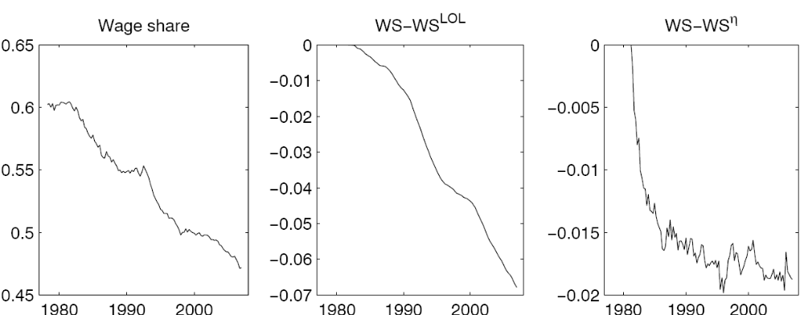

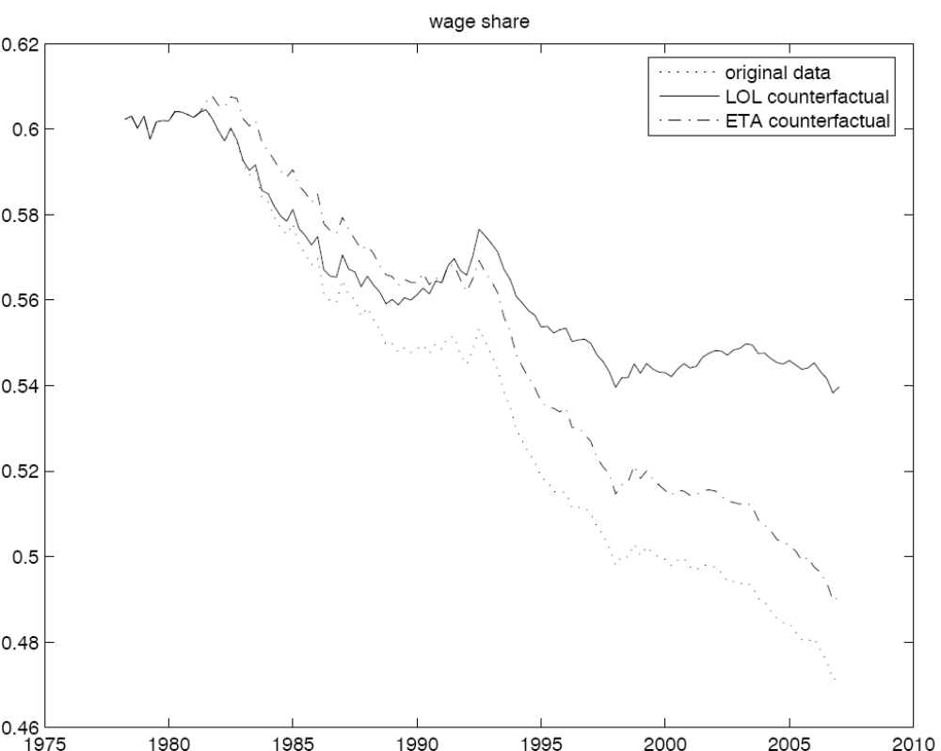

FIGURE A6.3 Counterfactual experiment:
upper plots show the actual wage share, the decline of the actual wage share which is explained by the decrease in labour overhead and in price mark-up. The bottom plot compares the actual wage share data with the two counterfactual experiments.

References

Oliveira-Martins, J. , Scarpetta, S., Pilat, D., 1997. Mark-up Pricing, Market Structure and the Business Cycle. OECD Economic Studies 27, Paris.

